#### 

#### **350W 5-36V Brushless Controller BLDC Wide Voltage High Power Three-phase**

**Description:**

* 100% Brand New and High Quality
* Wide voltage 5-36V, high power 350W, with heat sink, Lead wire, control switch etc. can be used directly
* Feature:
* 1.MA MB MC phase line output connection motor
* 2 5V GND motherboard comes with original
* 3.VCC GND external DC power supply line
* 4.SC pulse signal output
* 5.Z/F positive inversion control line 5V or GND to achieve positive and negative inversion
* 6.VR speed signal input, the general external 100K tripod middle pin potentiometer VR the remaining two feet 5V and GND main board.
* Specifications:
* Working voltage: 5-36V
* Maximum current: 16A
* Maximum power: 350W
* Over current protection
* Size: length 63mm x width 45mm x height 27mm
* Quantity: 1 Set
* Note:
* Please allow 1-3mm error due to manual measurement. pls make sure you do not mind before you bid
* Due to the difference between different monitors, the picture may not reflect the actual color of the item. Thank you!

**Package includes:**

* 1 x Brushless Controller Set

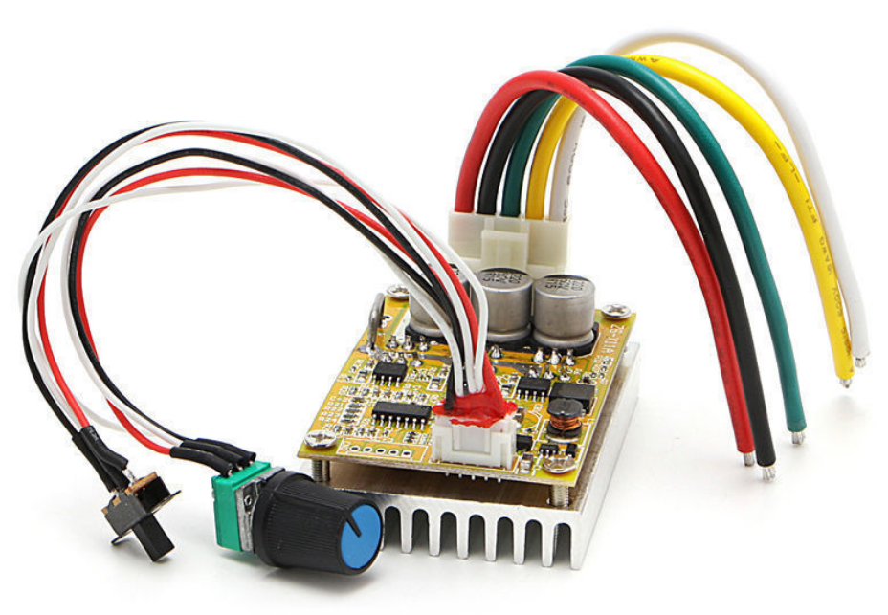

Sold by [**alicexi20**](http://myworld.ebay.com/alicexi20) ( [14360](http://feedback.ebay.com/ws/eBayISAPI.dll?ViewFeedback&userid=alicexi20) ) Delivered on **Tuesday, Jan 16, 2018+ Show shipping details**

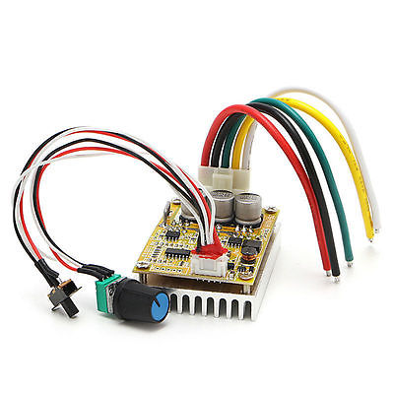

#### [**350W 5-36V Brushless Controller BLDC Wide Voltage High Power Three-phase**](http://www.ebay.com/itm/263026371172)

### ORDER DATE

### Jan 02, 2018

Sold by [**alicexi20**](http://myworld.ebay.com/alicexi20) ( [14360](http://feedback.ebay.com/ws/eBayISAPI.dll?ViewFeedback&userid=alicexi20) )

| **Item price** | $19.18 |
| --- | --- |
| **Quantity** | 2 |
| **Item number** | 263026371172 |

